Document 1: Beginners of a Nation

The history of English settlement in America began on a beautiful May morning, in 1607, when three ships anchored near the mouth of Chesapeake Bay. Once on the shore, men found “fair meadows and tall trees, with fresh waters.” With these ships were Captain John Smith and George Percy, the son of the Earl of Northumberland.
Percy records how they found “noble forests, the ground carpeted with flowers”, fruit “four times bigger than ours in England”, oysters “very large and delicate in taste”, much small game and many eggs. There was also an Indian town where the savages brought them corn bread and tobacco smoked in clay pipes with copper bowls.
These first experiences in Virginia seemed enchanting. Percy’s “Observations”, a beautiful narrative full of wild poetry, describes the delight of the newcomers. The richly-colored birds, fruit and berries and pleasant scenery are said to have “ravished” them.

Extract from « America : the History of a Free People » by Allan Nevins and Henry Steele Commange

Document 2 : What then is the American, this new man?
He is either a European, or the descendant of a European. I could point out to you a man whose grandfather was an Englishman, whose wife was Dutch, whose son married a French woman, and whose present four sons have now four wives of different nations. He is an American, who, leaving behind him his ancient prejudices and manners, embraces a new mode of life and obeys a new government. Here, individuals of all nations are melted into a new race of men. They belong to the finest systems of population which ever appeared.
Here the rewards of men follow with equal steps the progress of their labour. Wives and children, who before in vain demanded a morsel of bread, now, fat and merry, gladly help their father in the fields where exuberant crops are to arise to feed and to clothe them. No part will be claimed, by a despotic prince, a rich abbot, or a mighty lord. From servile dependence and penury, that new man will pass to labour of very different nature, rewarded by ample subsistence.That is an American.
Adapted from Letters from an American Farmer by Hector De Crèvecoeur, 1782

Document 3
Land being cheap and the forests being vast, labouring men, who know how to use fields and cattle, may easily establish themselves here. They will save a little money from the good wages they receive when they first work for others; that will allow them to buy land and begin their plantations. Multitude of poor people from England, Ireland, Scotland and Germany have, by this means, become wealthy farmers -when, in their own country, they could never have emerged from the poor condition in which they were born.
With the salubrity of the air and the healthiness of the climate, the increase of inhabitants is very rapid in America and becomes still more so by the arrival of strangers. Hence, there is a continual demand for more artisans of all kinds. Good workmen in any of those branches are sure to find employment and to be well paid for their work. If they are poor, they begin first as servants or journeymen; and if they are sober, industrious and frugal, they soon become masters and establish themselves in business.
Industry and constant employment are the two great ways to preserve the Morals and Virtue of a nation. Hence the fact that bad examples and infidelity are rare and that atheism is unknown here. And the Divine Being seems to have manifested his approbation of the way we treat each other by remarkable prosperity that favours the whole country.
B Franklin, The Autobiography of Benjamin Franklin, 1791
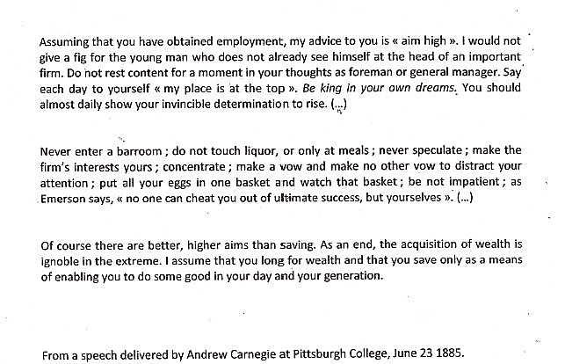
Document 4

